Carlos Alberto Barriga Gámez 20222020179

Cristian Santiago López Cadena 20222020027

**1. Project Description:**

The project consists of the development of monolithic software for an online store. In terms of technical decisions, the project was limited to the processes of purchasing items on the website and the appearance of the items purchased by the user within a tab called purchased items.

The companies that would use this software have a business model focused on the sales of various items through the Internet.

Concerning interested parties, we consider that the main interested parties in software with these characteristics are the owners of sales companies that intend to expand into online sales and all users who will benefit from being able to buy online. Likewise, we think that students in training can find in this project a tool to complement their knowledge through the review of software currently used by different companies.

Now, among the tools necessary to develop this software, and taking into account that it will be a monolith, it was decided to use Python for the development of the back-end together with the fast-api framework. For the graphical interface, it was decided to use HTML, CSS, JavaScript, Apache server, and Django framework. Finally, for the database, the SQLAlchemy software will be used, since it allows managing database relationships with a syntax similar to that of the programming language.

Because the software is required to be developed cooperatively, the GitHub software will be used to manage software versions.

Regarding the hardware that is required to be used for the development of the online sales platform, we will use 8 GB memory RAM, a 256 GB hard drive, and a tenth-generation Intel Core i5 processor.

**2. User Stories:**

**-** UH1: As a manager, I want a platform where I can publish the different products that I offer to anyone so that the number of sales increases.

* UH2: As a community manager I want my company logo to be seen on the main page so that all the users that enter can watch and recognize my company.
* UH3: As a manager, I want to display on the main page the products that I consider relevant to the customer and a banner for ads.
* UH4: As a manager, I want an option for the buyer to log in or register if not have an account, so I can identify the buyer in the future.
* UH5: As a buyer, I want to create an account to be able to see all the purchases I made on the platform.
* UH6: As a buyer, I want to create an account to save my shipping address, so that I can use it in future purchases.
* UH7: As a buyer, I want to access the main page and be able to select the product I want to buy.
* UH8: As a buyer, I want to see the products in the main interface, with name and price, and also an image to identify it more easily and thus select the option that I consider appropriate.
* UH9: As a manager, I want the application not to show those products that are out of stock.
* UH10: As a manager, I want it to be verified at the time of payment that the user or buyer has identified themselves as a user of the application and if not, force them to identify themselves.
* UH11: As a buyer, I want to be able to purchase more than one unit of a product and be able to see the total that I need to pay.
* UH12: As a buyer, I would like to have a search bar in which I can search for the product I want.
* UH13: As a buyer, I want to be able to use different filters and more easily access the product I want.
* UH14: As a manager, I want to provide the platform with a way to search for products by name and display the searched product and similar products that may interest the buyer on the same page.
* UH15: As a manager, I would like to be able to add information about the products that are for sale such as their name, current stock, main characteristics, department to which the product belongs, price, description, images of the product, and store that sells the product.
* UH16: As a manager, I want to show a product preview with the following structure: a general product image, the name, the price, and a button to purchase.
* UH17: As a manager, I want the preview to go to a main view in which all the details of the product are seen but the purchase button is maintained.

**3. UML Diagrams**

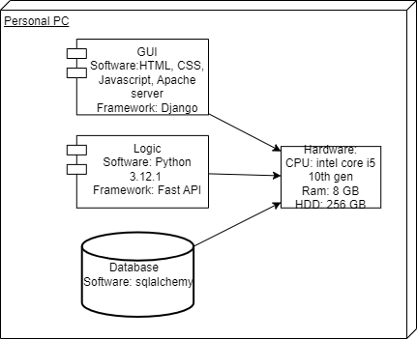**Deploy diagram**

* 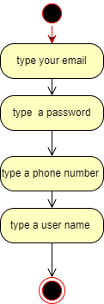**Activity Diagram: Create account.**
* 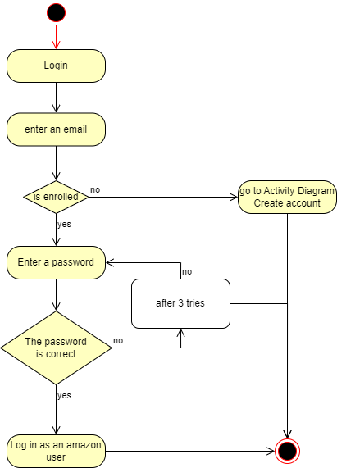**Activity Diagram: Login.**
* 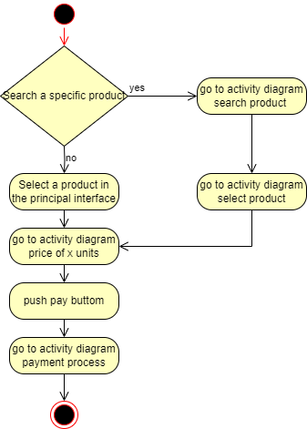**Activity diagram: buy the product**
* **Activity Diagram: Payment Process.**

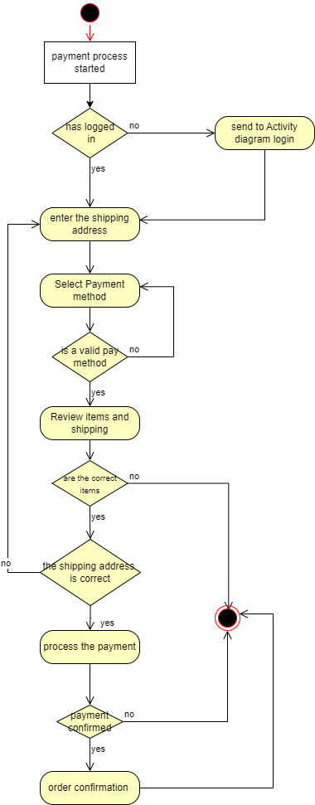

* Texto

  Descripción generada automáticamente**Activity Diagram: Post Product.**
* **Activity diagram: search product.**

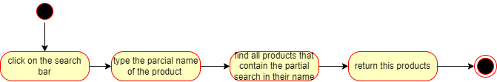

* **Activity diagram: select product.**

* **Activity diagram: Price of x units.**

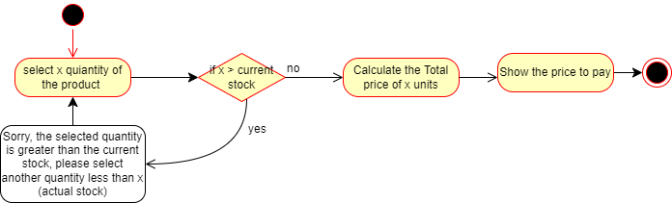

* 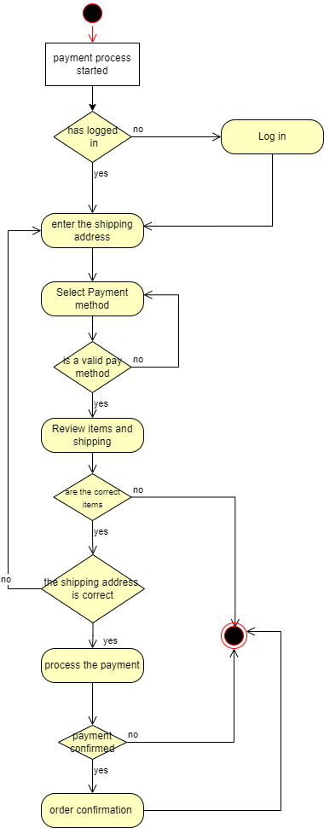**Activity diagram: payment process.**
* 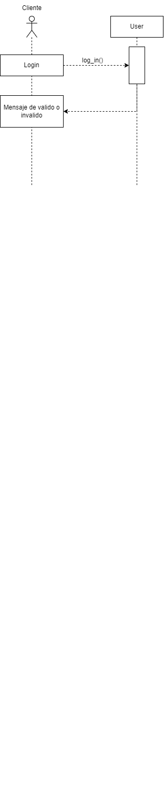**Sequence Diagram: Login**
* 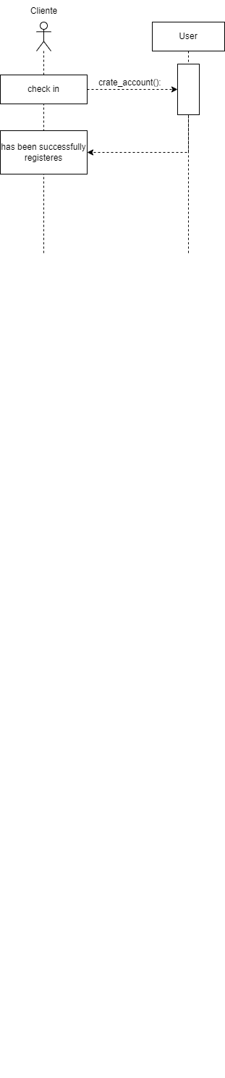**Sequence Diagram: Create user**
* 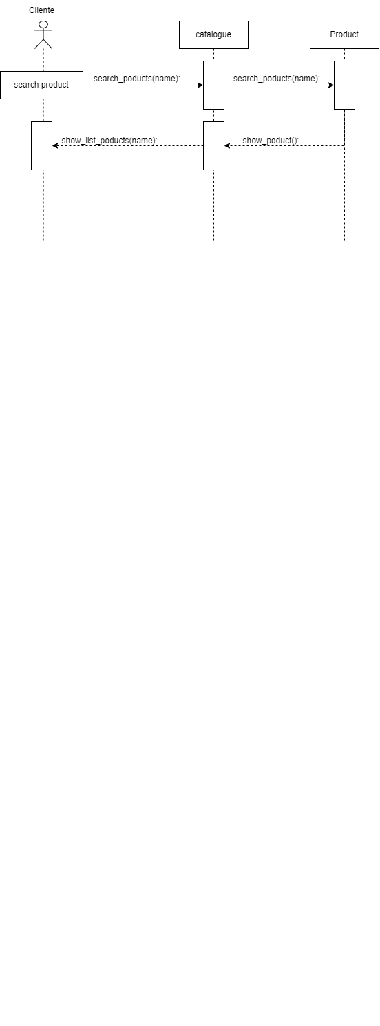**Sequence Diagram: Search Product**
* 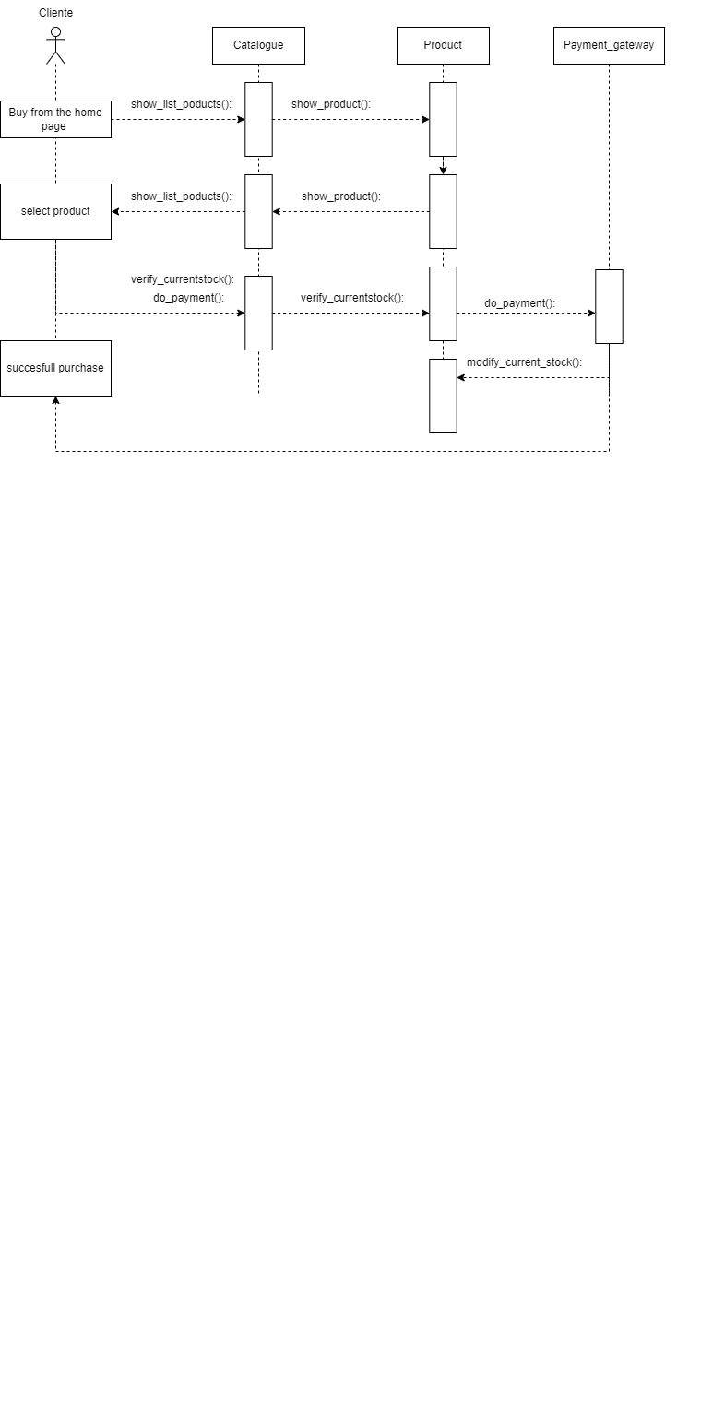**Sequence Diagram: Buy product.**
* **Sequence diagram: modify current stock**

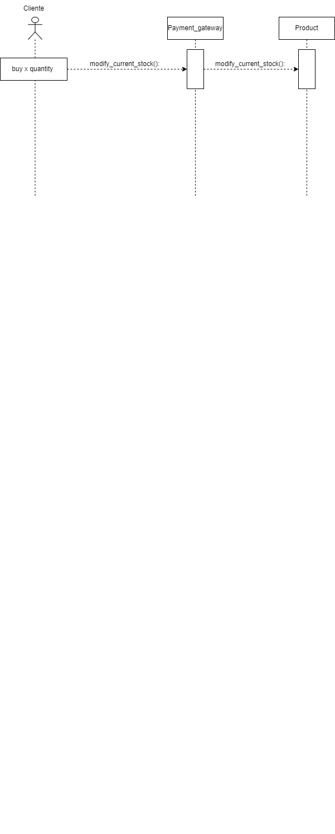

* **Sequence diagram: add product**

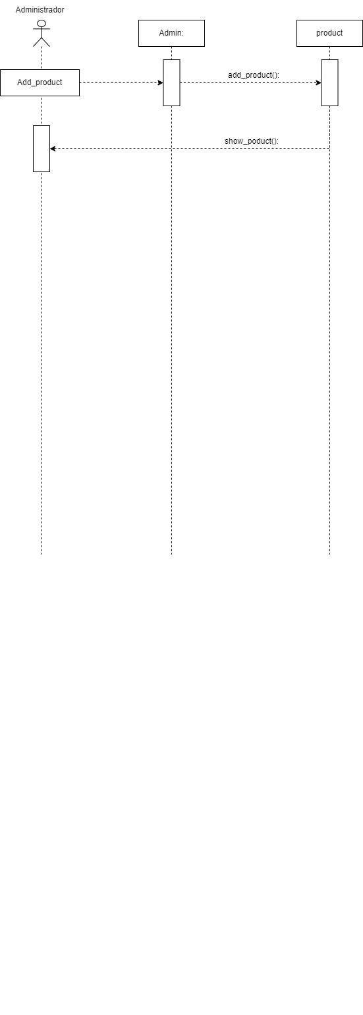

* **State diagram: User**

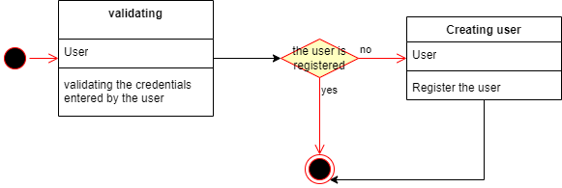

* **State diagram: Costumer**

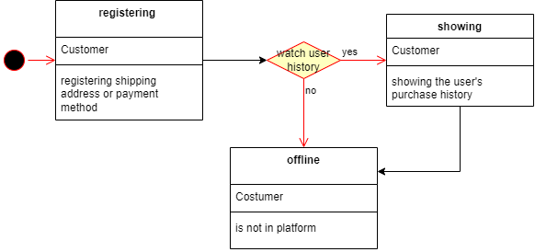

* **State diagram: Admin**

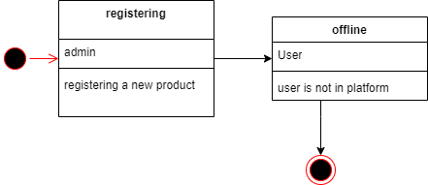

* **State diagram: credit card**

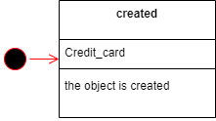

* **State diagram: Product**

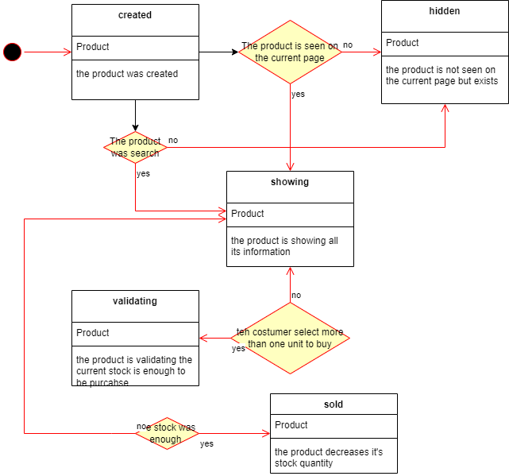

* **State diagram: Payment gateway**

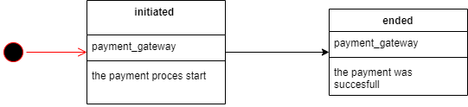

* 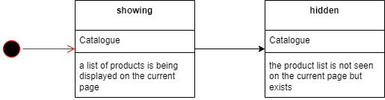**State diagram: Catalogue**

**4. CRC Cards**

|  |  |
| --- | --- |
| User | |
| Responsibility | Collaborator |
| * Create accounts * Allow user to log in | Costumer and Administrator |

|  |  |
| --- | --- |
| Customer | |
| Responsibility | Collaborator |
| * Save the shipping address * Save pay method * Save customer purchase history | Credit_card |

|  |  |
| --- | --- |
| Admin | |
| Responsibility | Collaborator |
| * Add new products |  |

|  |  |
| --- | --- |
| Credit_card | |
| Responsibility | Collaborator |
| Have the attributes number, expiration date, cvv, name. |  |

|  |  |
| --- | --- |
| Product | |
| Responsibility | Collaborator |
| * Show all the product info * Verify the current stock | Catalogue |

|  |  |
| --- | --- |
| Payment gateway | |
| Responsibility | Collaborator |
| * Do the payment * Save the product on user history * Modify the current stock | Catalogue  Customer  Product |

|  |  |
| --- | --- |
| Catalogue | |
| Responsibility | Collaborator |
| * Show the list of products available * Search products by name | Product |

**5. data types.**